**Practical No**

**//Perform Steps to create Article in Drupal**

Step 1 - Login in WordPress Administrator (Node)

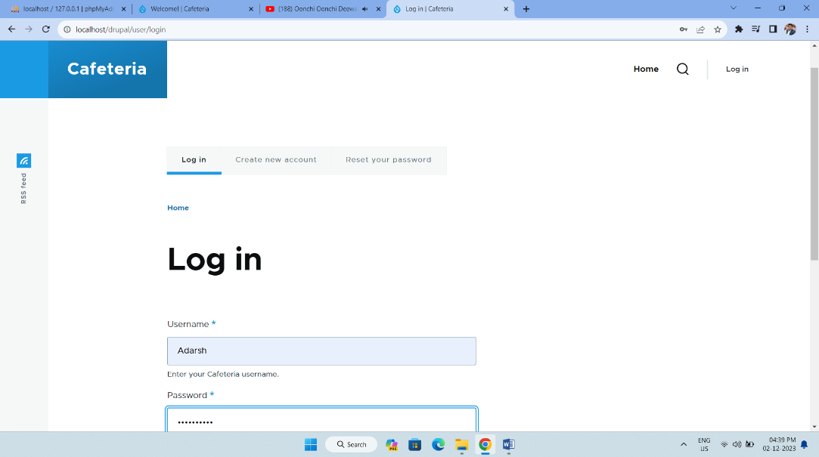

Step 2 - Select Content option and add new Content

Content > Add content > article

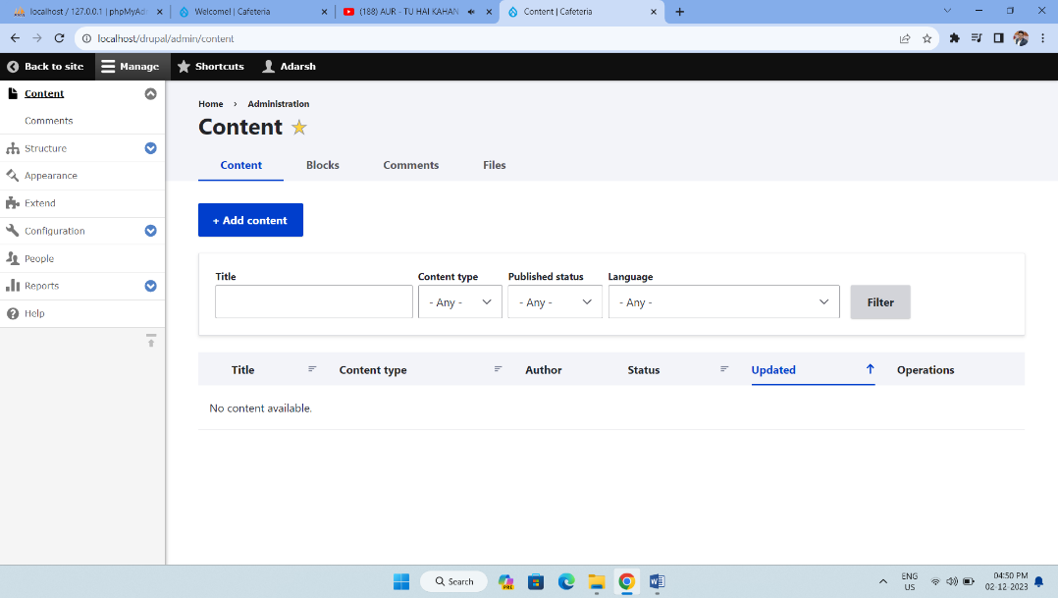

Step 3 - The Create Basic page form appears.

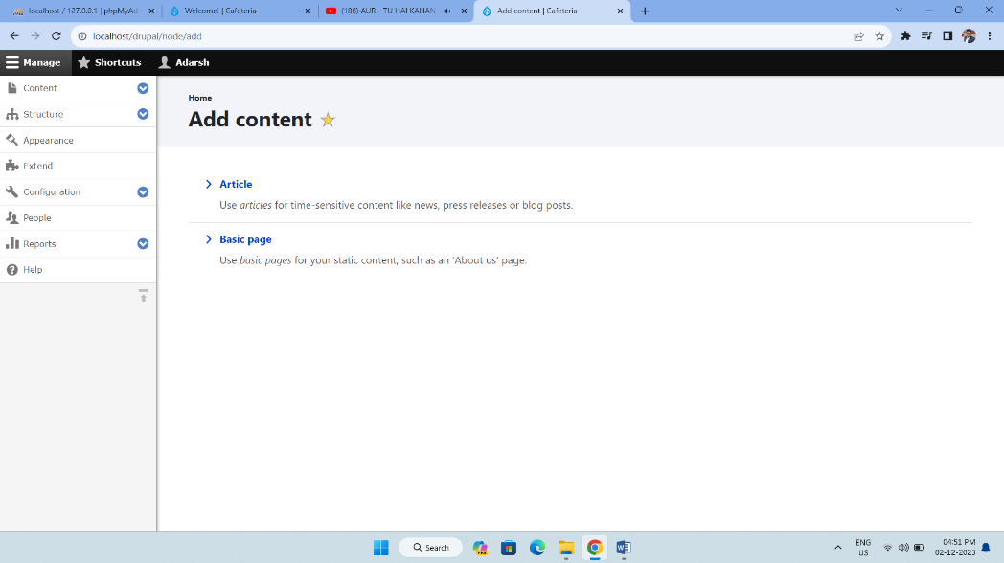

Step 4 - To add text, you just click and type.

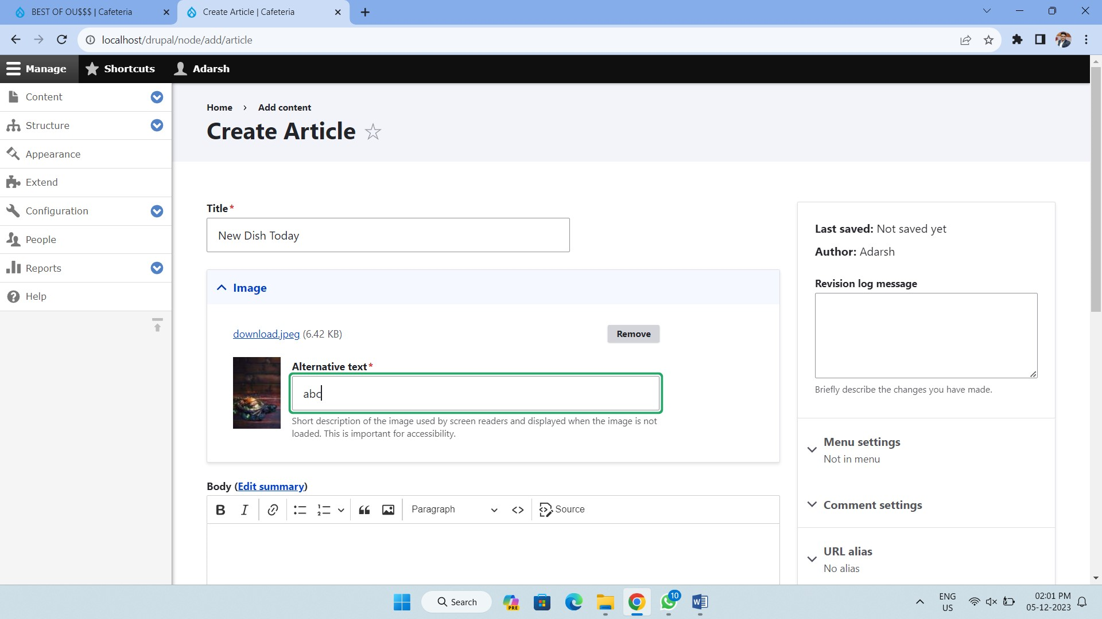

Step 5 - Front End (Content Created, Modified, Published)

